EXPERIMENT 10
AIM:
PERFORMANCE ANALYSIS OF FM SYSTEM UNDER GAUSSIAN WHITE NOISE USING MATLAB

SOFTWARE REQUIRED:
MATLAB Simulation

PROGRAM:
Clc;
Clear;
Close all;
Fs = 10000;
T = 0:1/Fs:0.1;
Am = 1;
Fm = 100;
Fc = 1000;
Kf = 1000;
M = Am*cos(2*pi*fm*t);
S = cos(2*pi*fc*t + kf*cumsum(m)/Fs);

Noise = 0.3*randn(size(t));
R = s + noise;

Y = fmdemod(r,fc,Fs,kf/(2*pi));
Y = y – mean(y);

Figure;
Subplot(4,1,1);
Plot(t,m);
Title(‘Message Signal’);
Grid on;

Subplot(4,1,2);
Plot(t,s);
Title(‘FM Modulated Signal’);
Grid on;

Subplot(4,1,3);
Plot(t,r);
Title(‘FM Signal with Gaussian Noise’);
Grid on;
Subplot(4,1,4);
Plot(t,y);
Title(‘Demodulated Signal’);
Grid on;
Sgtitle(‘FM Performance Under Gaussian White Noise’);

GRAPH:
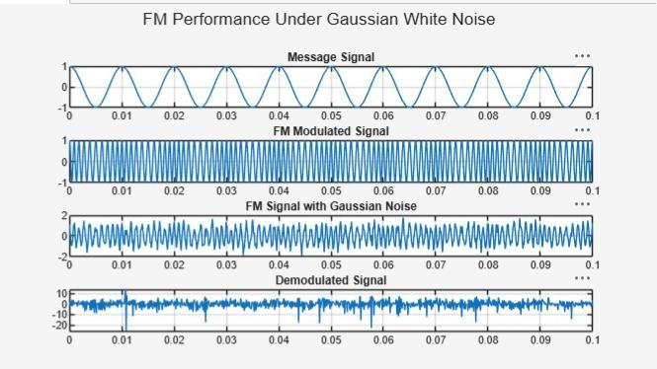

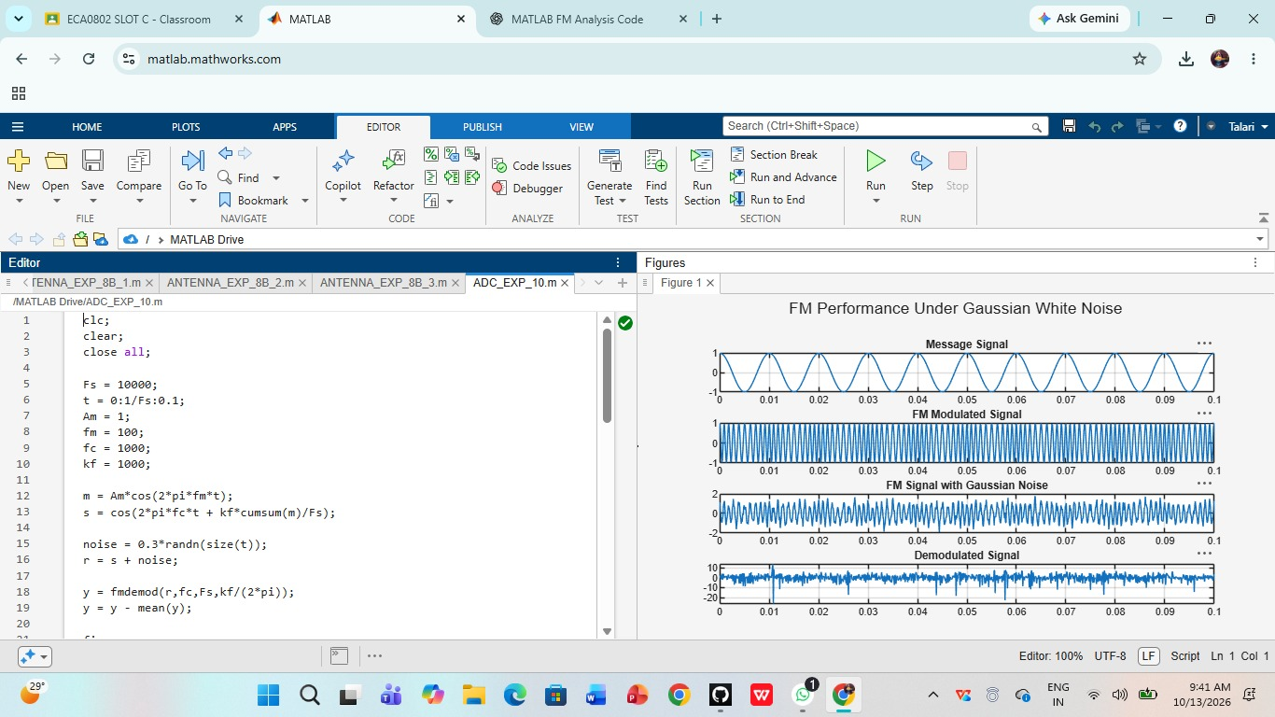
OUTPUT:
RESULT:
The FM system under Gaussian white noise was successfully simulated using MATLAB. The effect of noise on the FM signal was analyzed, and the original message signal was recovered through demodulation. The signal quality improved with an increase in SNR.

